Week 4 Calculator in C

Robert Brenckman
Charter Oak State College
ITE 215: Software Develop Method & Languages
COSC_ITE215012526FACR
John Rusnak
11/17/2025
Addition
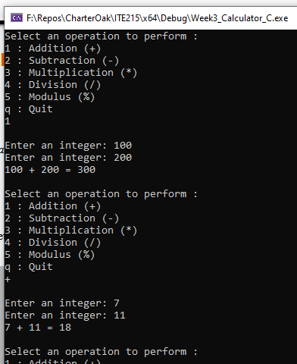

Subtraction
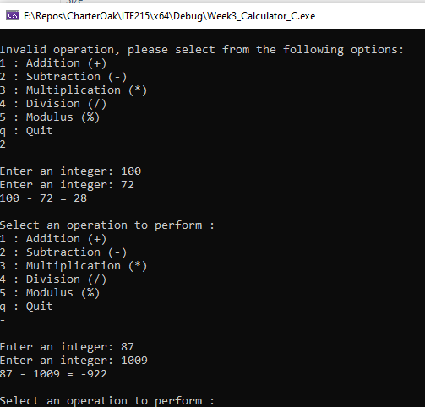

Multiplication
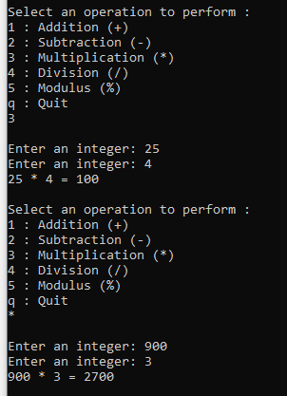
Division
Success | Invalid Divisor
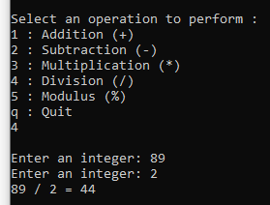 | 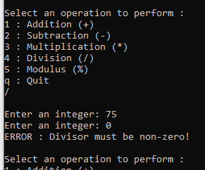

Modulo
Success | Invalid Divisor
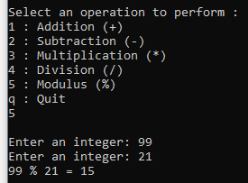 | 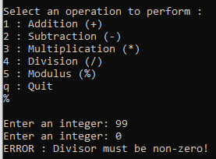

Quit
